ASSIGNMENT 7.3
ENROLL NO:2403A52101
Task Description #1:
• Start a Python class named Student with attributes name, roll_number, and marks. Prompt GitHub Copilot to complete methods for displaying details and checking if marks are above average.
Expected Outcome #1:
• Completed class with Copilot-generated methods like display_details() and is_passed(), demonstrating use of if-else conditions.
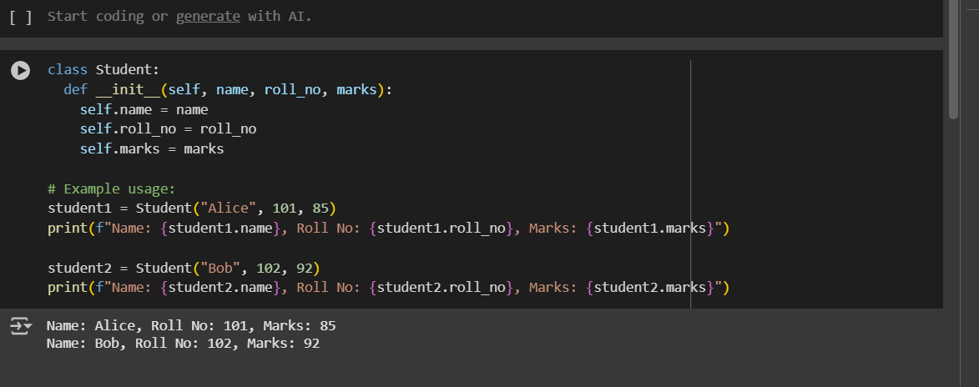
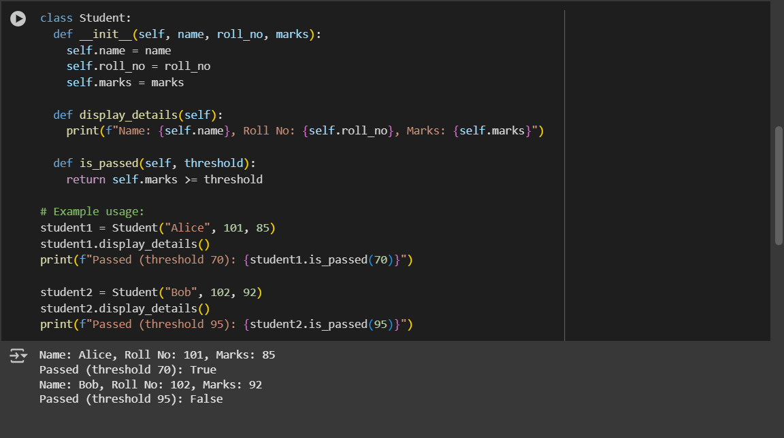
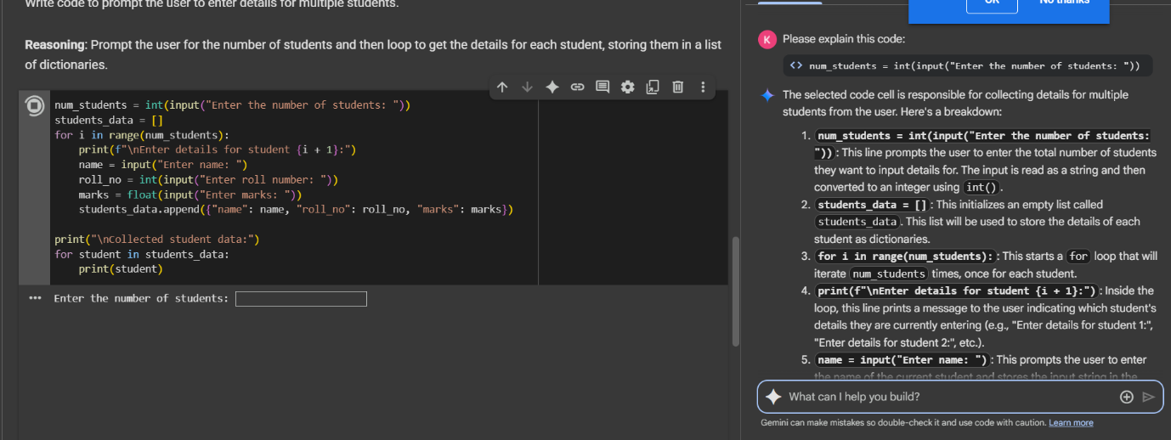
Task Description #2:
• Write the first two lines of a for loop to iterate through a list of numbers. Use a comment prompt to let Copilot suggest how to calculate and print the square of even numbers only.
Expected Outcome #2:
• A complete loop generated by Copilot with conditional logic (if number % 2 == 0) and appropriate output.
